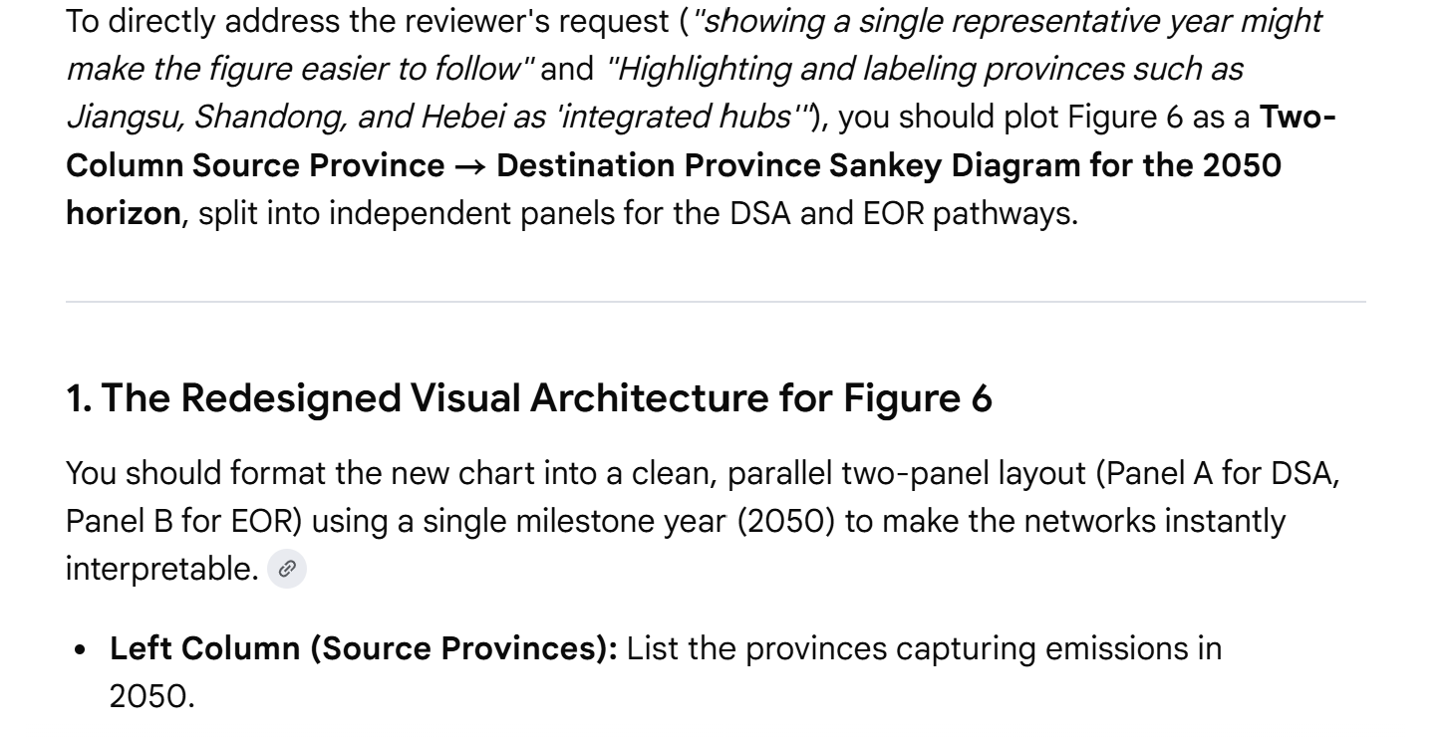
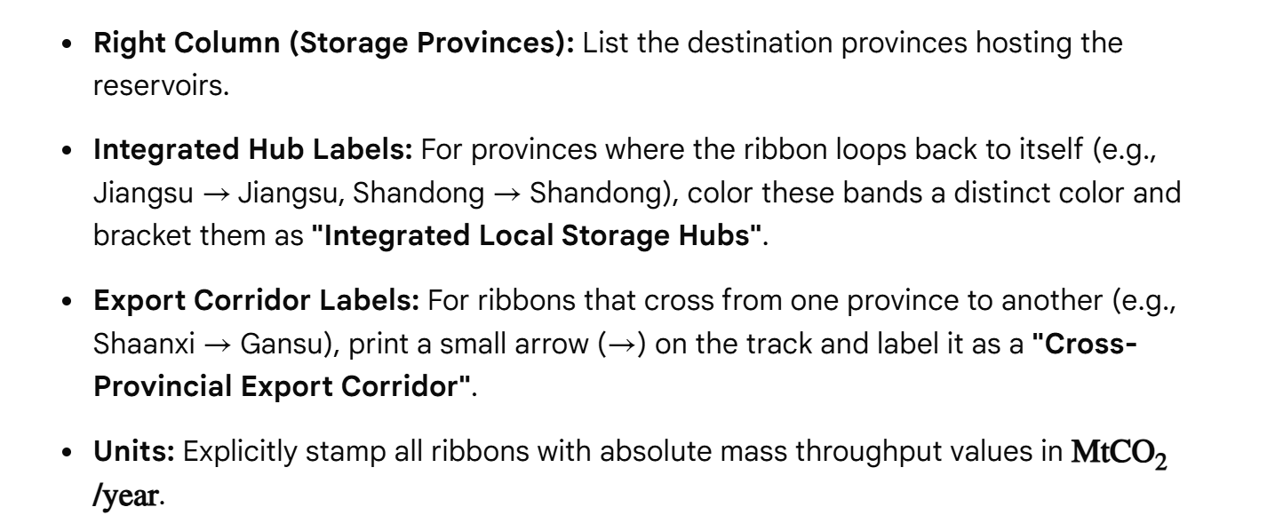
You don’t need to write integrated local hubs or cross-provincial export corridor on the chart directly. You can write it in the Legend.
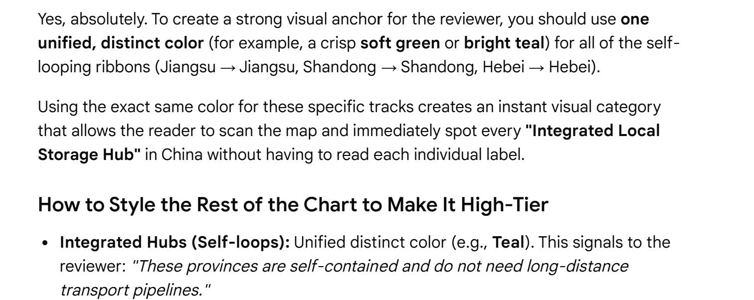
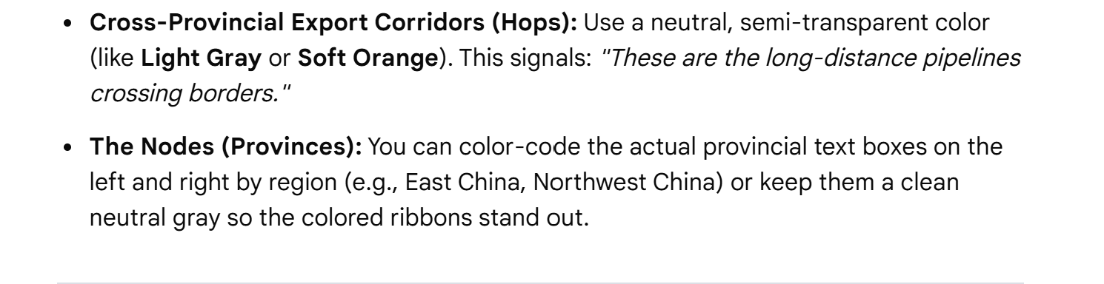
On the chart there will be only two colors, showing "Integrated Local Storage Hubs"and "Cross-Provincial Export Corridor".
I still think it is better to show from 2025 to 2050.
We should write the amount stored in each province by each year. The amounts increase as you move from 2025 to 2050 as you keep adding the carbon to the storage. For ribbons showing cross-provincial flow, we should write the amount of carbon being transported at that time which we should consider wen determining the amount stored in that province by that year. write the amount in Gt so it doesn't take a lot of space

